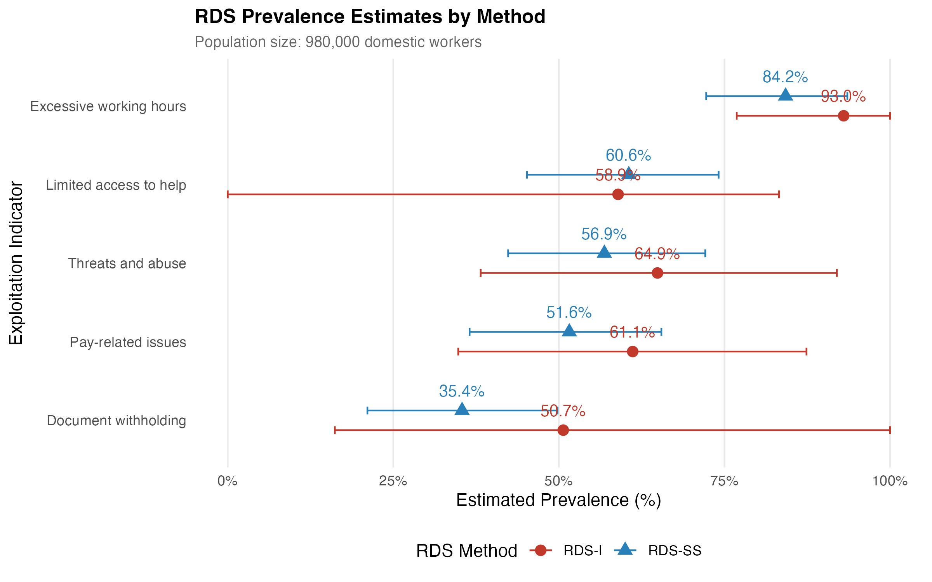
Figure 4. RDS Prevalence Estimates by Method (RDS-I vs RDS-SS). Point estimates and per-method bootstrap 95% confidence intervals for the five binary exploitation indicators at N=980,000 domestic workers. RDS-I (Salganik-Heckathorn) shown in red; RDS-SS (Gile's Successive Sampling) shown in blue. Source: Authors' own work.

